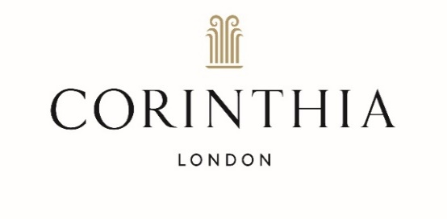
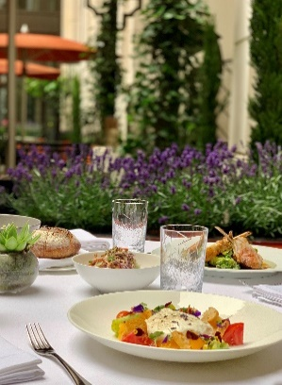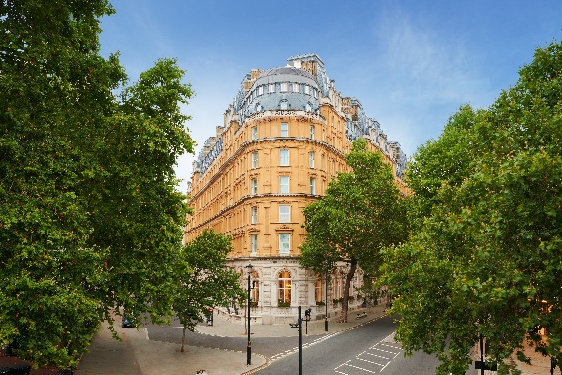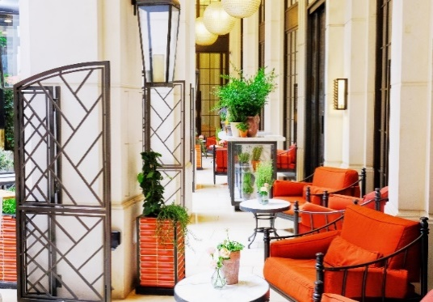

CORINTHIA LONDON LAUNCHES MEDITERRANEAN-INSPIRED THE GARDEN

Corinthia London is delighted to announce that their al fresco restaurant - The Garden - will reopen on 12 April 2021.

Designed by David Collins Studio, Corinthia’s secluded courtyard will be transformed into a Mediterranean garden with lemon and olive trees, herbs and bougainvillea. Scents of lavender and jasmine will reawaken memories of past visits to favourite European holiday destinations. The signature Mediterranean menu created by Executive Chef André Garrett will feature seafood dishes from the raw bar, salads, and gourmet pizzas baked to order in a wood-fired oven.

Typical Dishes
Fritto misto
Yellowtail tartare with apple, lemon and coriander
Lobster linguine with lemon, cherry tomatoes and basil
Grilled brill with fennel and Champagne
Fiorentina steak with rocket, basil and anchovies
Frozen berries with white chocolate sauce
Fraises des bois with whipped vanilla crème Chantilly

“My team and I had great fun putting this menu together, reminiscing about dishes from our favourite Mediterranean holidays” said Corinthia London’s Executive Chef André Garrett. “The Garden is the perfect spot for guest to enjoy an al fresco meal and drinks with family and friends, surrounded by fragrant foliage.”

To complement the idyllic setting, guests will be able to choose from a selection of rosé wines, including Whispering Angel, Domaines Ott, Miraval, and Minuty, as well as refreshing seasonal cocktails, such as Rosé Piscines, Aperol and Campari Spritzes, and Watermelon Martinis.

“Fond recollections of summer holidays seem but a distant memory. Our Mediterranean garden will offer the chance to enjoy much-loved dishes from Europe surrounded by fragrant foliage,” enthused Thomas Kochs, Corinthia London’s Managing Director. “With travel restrictions in place, we hope that The Garden will offer a cure for wanderlust. An al fresco lunch with a glass of refreshing, pale rosé is the perfect way to enjoy the spring and summer months and we are delighted to have partnered with Domaines Ott with a delectable range of wines.”

The Garden will be open daily, and the Mediterranean menu will be available from Noon until 11pm. Prices will range from £11 for starters, from £24 for main courses, and desserts from £10. Note that Corinthia London, and The Garden, will constantly monitor any updates to government guidelines re Covid-19. The hotel and its other restaurants (The Northall, Kerridge’s Bar & Grill, The Crystal Moon Lounge), bars (Bassoon, The Northall), and bedrooms will open fully from 17 May 2021.

More details are available on the website – www.corinthia.com/london/restaurants-bars/
The Garden, Corinthia London, Whitehall Place, London SW1A 2BD
Instagram - @corinthialondon #FindMeAtTheGarden

- ENDS –

Media contact: Alice Jónsdóttir Ferrier - Email: alice.jonsdottir@corinthia.com, or Tel: +44 (0) 207 321 3182

March 2021

